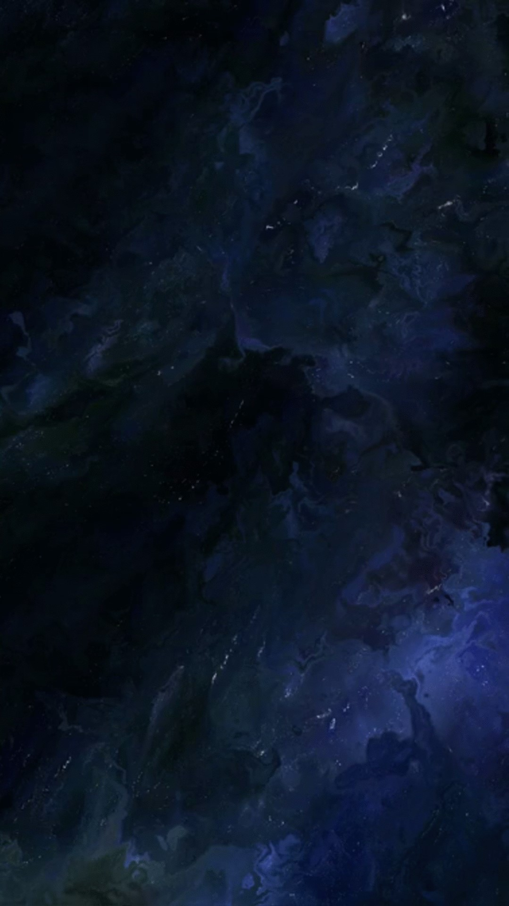

Planets near and far: Build a Planet



**Prepare to be a Cosmo’s builder in a new educative and exciting experience!**

In “Star System Simulator Environment” you can create your own solar system, customize the features and components of a celestial body while you learn and enjoy about the laws that involve this system.

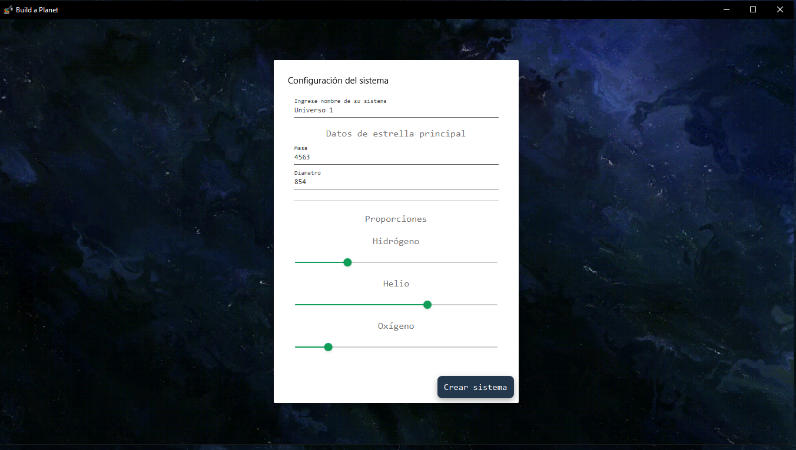

You begin with a star, the core of a system, choosing it chemical and physical composition like mass, density, temperature, average power, angular speed and gravitational field.

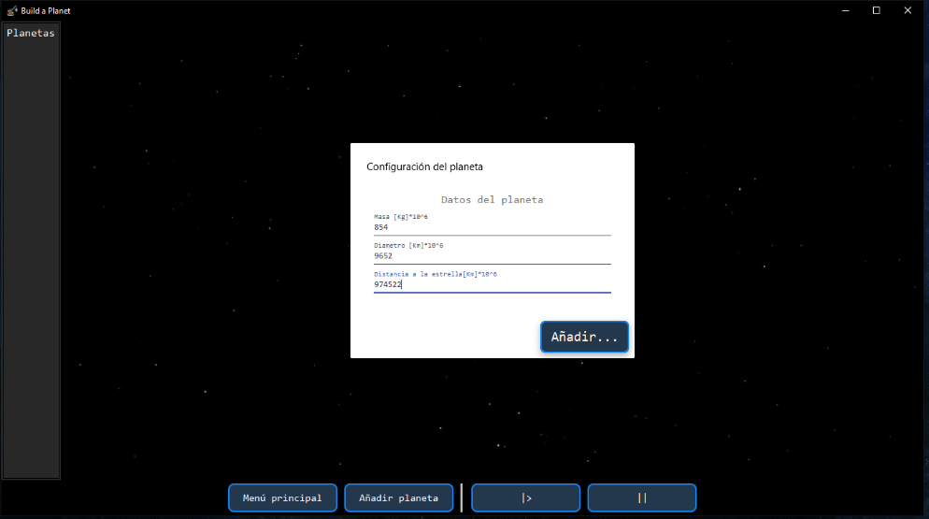 The next step its planet design. As previous, the player can customize the values, like radius, which depend of the properties of the Star created.

.

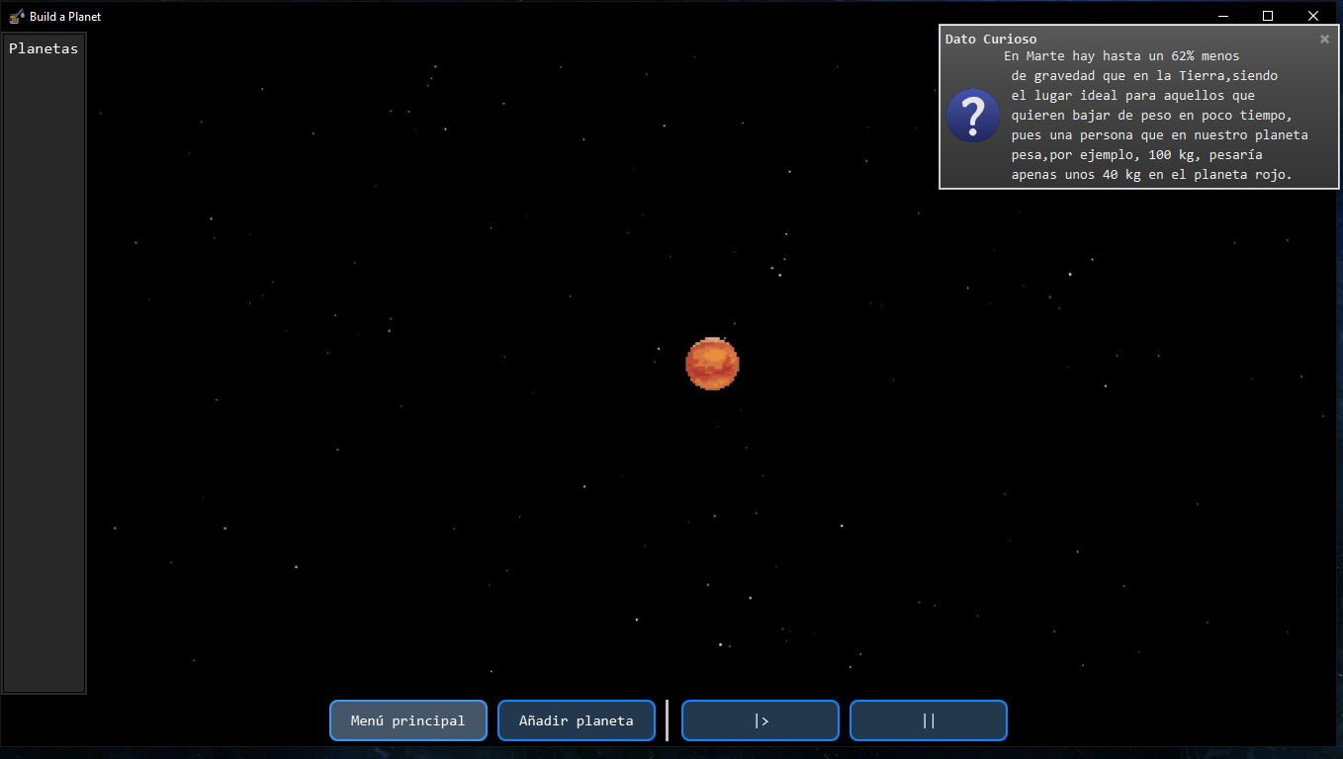

Along the way the game develops, information like tips, warnings, about the information you select for your system, and curiosities will show in the screen using the material provided by Nasa, always applying chemical and physical knowledge.

